

**Universidad Tecnológica de Puebla**

Desarrollo de Aplicaciones

* Schiaffini Corona José Gilberto.

3° Cuatrimestre

Mayo-Agosto

Grupo: “H”

Evidencia

Examen 1.

Profesora: Jenny Ortega García

**Forms.**

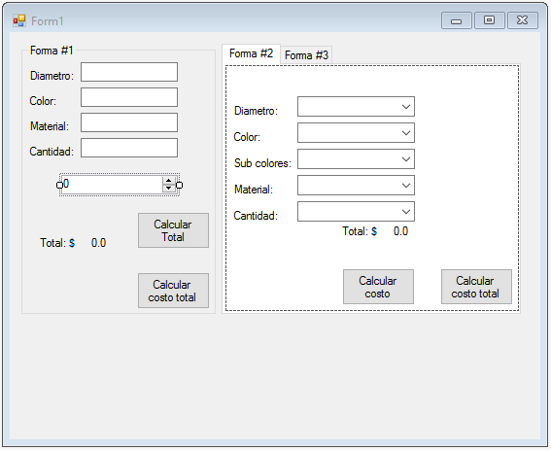

**Formulario.**

using System;

using System.Collections.Generic;

using System.ComponentModel;

using System.Data;

using System.Drawing;

using System.Linq;

using System.Text;

using System.Threading.Tasks;

using System.Windows.Forms;

namespace WindowsFormsApplication1

{

public partial class Form1 : Form

{

public Form1()

{

InitializeComponent();

}

Costo f1 = new Costo();

int indi = 0;

double[] arre2 = new double[9];

double total2 = 0;

private void btnCalcular2_Click(object sender, EventArgs e)

{

if (indi <= 9)

{

int diame = Convert.ToInt32(cmbDiametro.Text);

int cantidad=Convert.ToInt32(cmbCantidad.Text);

string color=cmbColor.Text;

string subcolor=cmbSubColor.Text;

string material=cmbMaterial.Text;

f1.CalcularCosto2(diame, cantidad, color, subcolor, material, ref total2);

arre2[indi] =total2;

lblTotal2.Text=total2.ToString();

indi++;

}

}

private void btnCostoTotal2_Click(object sender, EventArgs e)

{

double sume = arre2.Sum();

MessageBox.Show("El total es de: " + Convert.ToString(sume));

}

**Clase.**

public void CalcularCosto2(int diame, int cantidad, string color, string subcolor, string material, ref double total)

{

if ((diame == 9 && color=="Frios"&& material=="Plastico" )&& (subcolor=="Verde"|| subcolor=="Violeta"|| subcolor=="Azul" ))

{

total = (7 + 1.9 + 6) * cantidad;

}

else if ((diame == 9 && color == "Calidos" && material == "Plastico") && (subcolor == "Amarillo" || subcolor == "Naranja" || subcolor == "Rojo"))

{

total = (7 + 1.5 + 6) * cantidad;

}

else if ((diame == 9 && color == "Frios" && material == "Piel") && (subcolor == "Verde" || subcolor == "Violeta" || subcolor == "Azul"))

{

total = (7 + 1.9 + 12) * cantidad;

}

else if ((diame == 9 && color == "Calidos" && material == "Piel") && (subcolor == "Amarillo" || subcolor == "Naranja" || subcolor == "Rojo"))

{

total = (7 + 1.5 + 12) * cantidad;

}

else if ((diame == 9 && color == "Frios" && material == "Goma") && (subcolor == "Verde" || subcolor == "Violeta" || subcolor == "Azul"))

{

total = (7 + 1.9 + 8) * cantidad;

}

else if ((diame == 9 && color == "Calidos" && material == "Goma") && (subcolor == "Amarillo" || subcolor == "Naranja" || subcolor == "Rojo"))

{

total = (7 + 1.5 + 8) * cantidad;

}

}